

TO WHOMSOEVER IT MAY CONCERN
Date: - 16/08/2022

This is to certify that Krishnkant Nagda, Diploma, Computer Science, student of Vidya Bhawan Polytechnic College, has successfully completed his training on PYTHON and HTML, CSS. with Geekstairs Technologies during the period 12 July, 2022 to 16 August, 2022.
During the course of training, Krishnkant Nagda has shown great amount of responsibility, sincerity and a genuine willingness to learn and zeal to take on new assignments & challenges. In particular, his coordination skills and communication skills are par excellence and his attention to details is impressive.
We wish him all the very best for his future.

With regards,

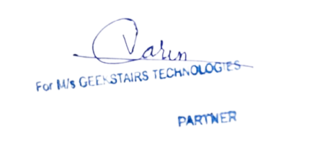

Varun Nagda
Founder & COO

